**Our UK Guide to Sport in 2015**

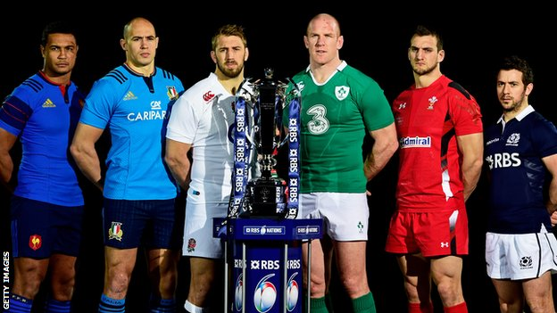

It’s going to be an incredible year in 2015 for British sport. The domestic talent produced right here on these shores these days is quite phenomenal and in 2015 we’ll be able to watch, support and cheer on all our favourite British sportsmen and women as they go head to head with the biggest and most talented names in sport from around the world on a global stage.

It’ll be a fantastic year all round for rugby fans with not just one but two amazing tournaments to savour. Not only will you get to enjoy the 2015 [Six Nations Championship](http://www.rbs6nations.com/en/home.php) in February but just seven months later will arrive the England hosted 2015 Rugby World Cup.

February’s 6 nations will pit England, France, Ireland, Italy, Scotland and Wales together to find the best team on the field. A victory which Ireland enjoyed thoroughly back in March 2014. Wales and England will kick off the proceedings on Friday 6th February 2015 at the Millennium Stadium in Cardiff and will fight it out for the win.

This past summer British Wimbledon champion Andy Murray crashed out of the tournament in the quarter finals defending his long-awaited title. The 27-year old Glaswegian will be looking to return to the All England Club in 2015 to regain his title that he incredibly landed back in 2013 in a thrilling final against Serbia's Novak Djokovic, who currently holds the title. But Murray will have his work cut out as 7-time Wimbledon champion Roger Federer also has his eye on yet another Grand Slam tournament title in 2015.

Racing fans haven’t been left out in 2015 either and will be able to relish two of the biggest dates in the horse racing calendar. [The Cheltenham Festival](http://www.freebets.com/gold-guide-to-cheltenham-2015) opens its’ doors on 10 March promising all the usual thrills and excitement that comes with the event. With hot tips and odds that’ll appeal to seasoned betters or even those who just enjoy a fun flutter there’s something for everyone at the Cheltenham racecourse.

Of course the Cheltenham Festival isn’t the only major horse racing event taking place in 2015. The [Crabbie’s sponsored 2015 Grand National](http://www.thecrabbiesgrandnational.co.uk/) from Aintree will be ran and fought fiercely to the very last furlong in April with all riders looking to avoid the dreaded fall and hoping to successfully jump all 30 fences, included the famous Bechers Brook, in order to ride to victory.